LAB – 03

**AUTO SCALING**:

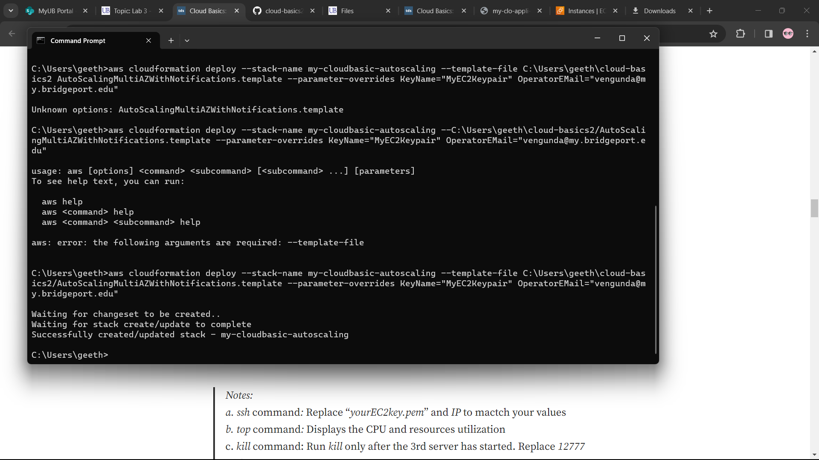

1. Running servers successfully.

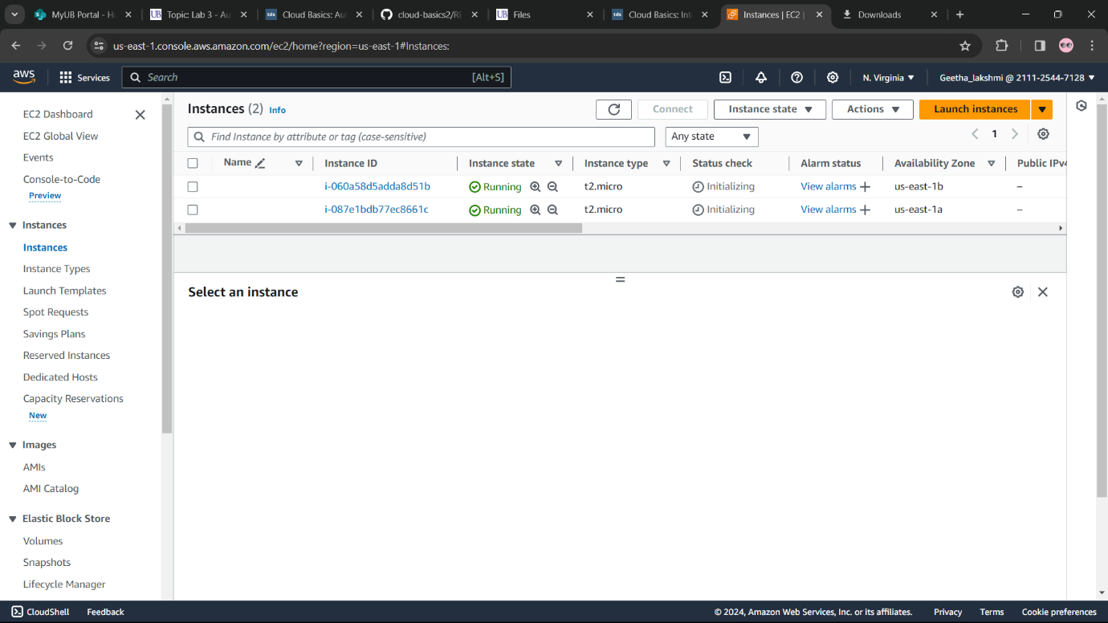

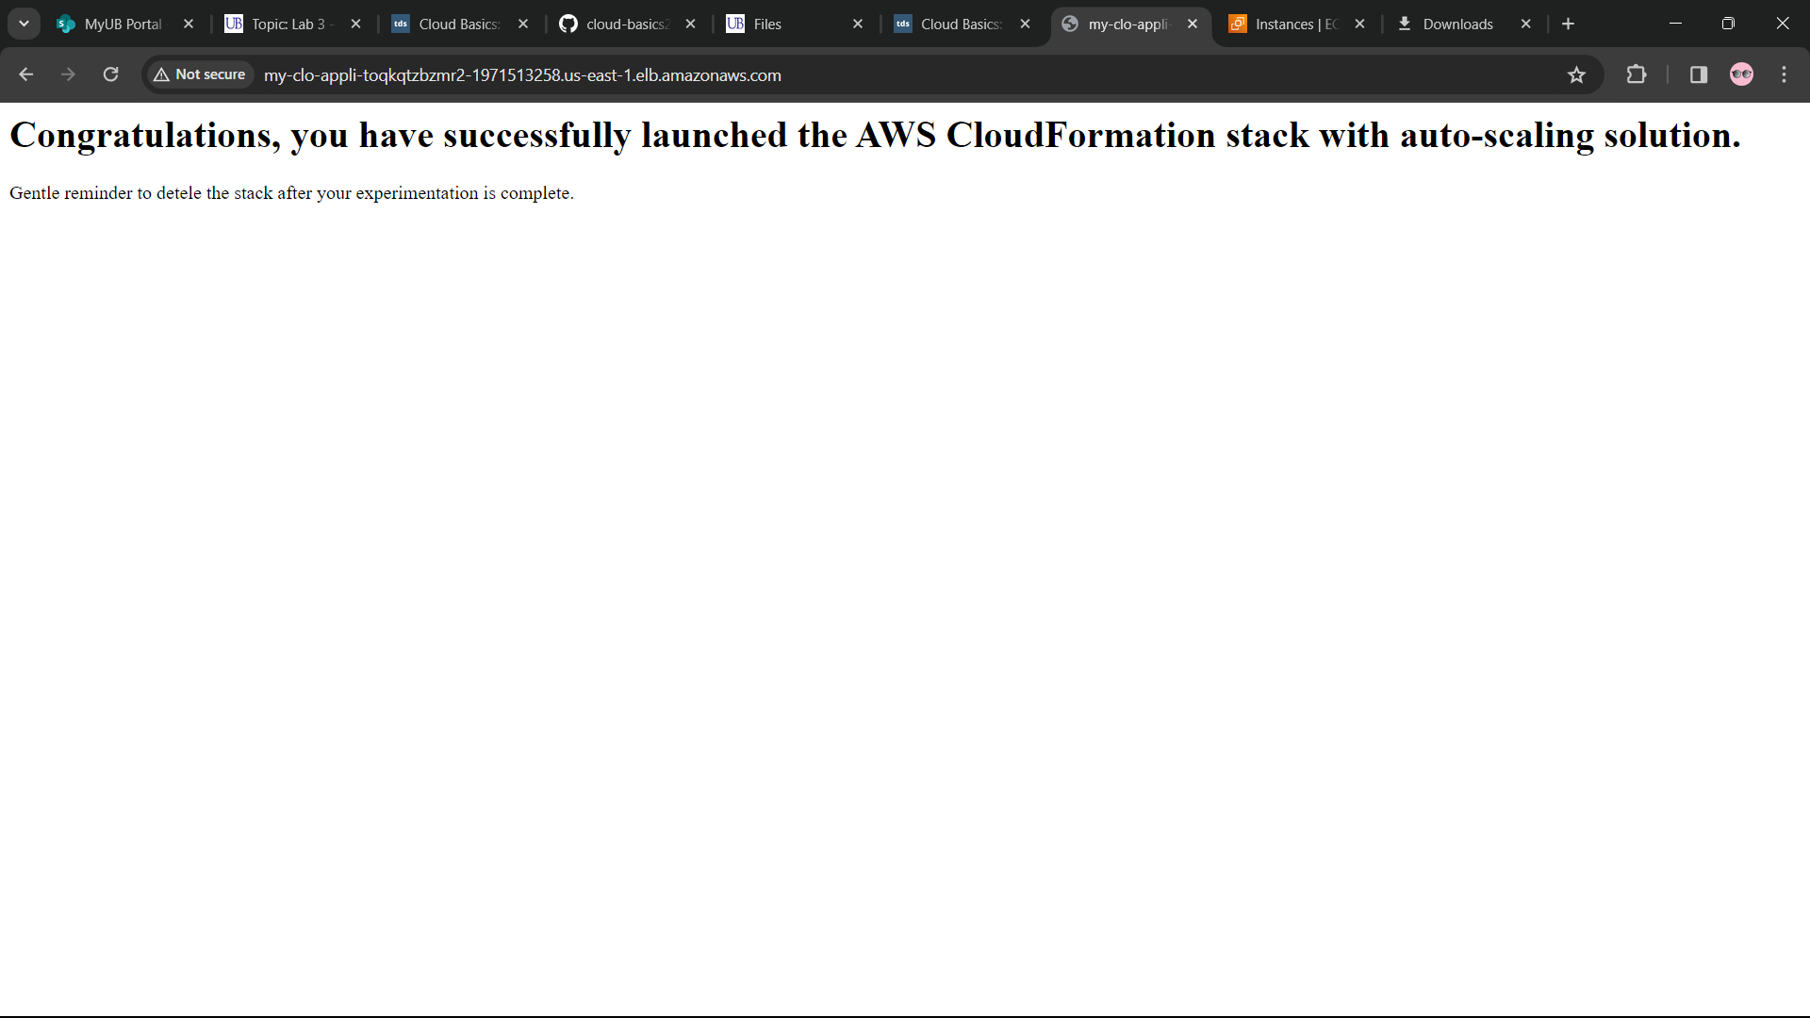

**Workload based auto-scaling**:

1. Increasing the CPU of the two servers to 90% above.

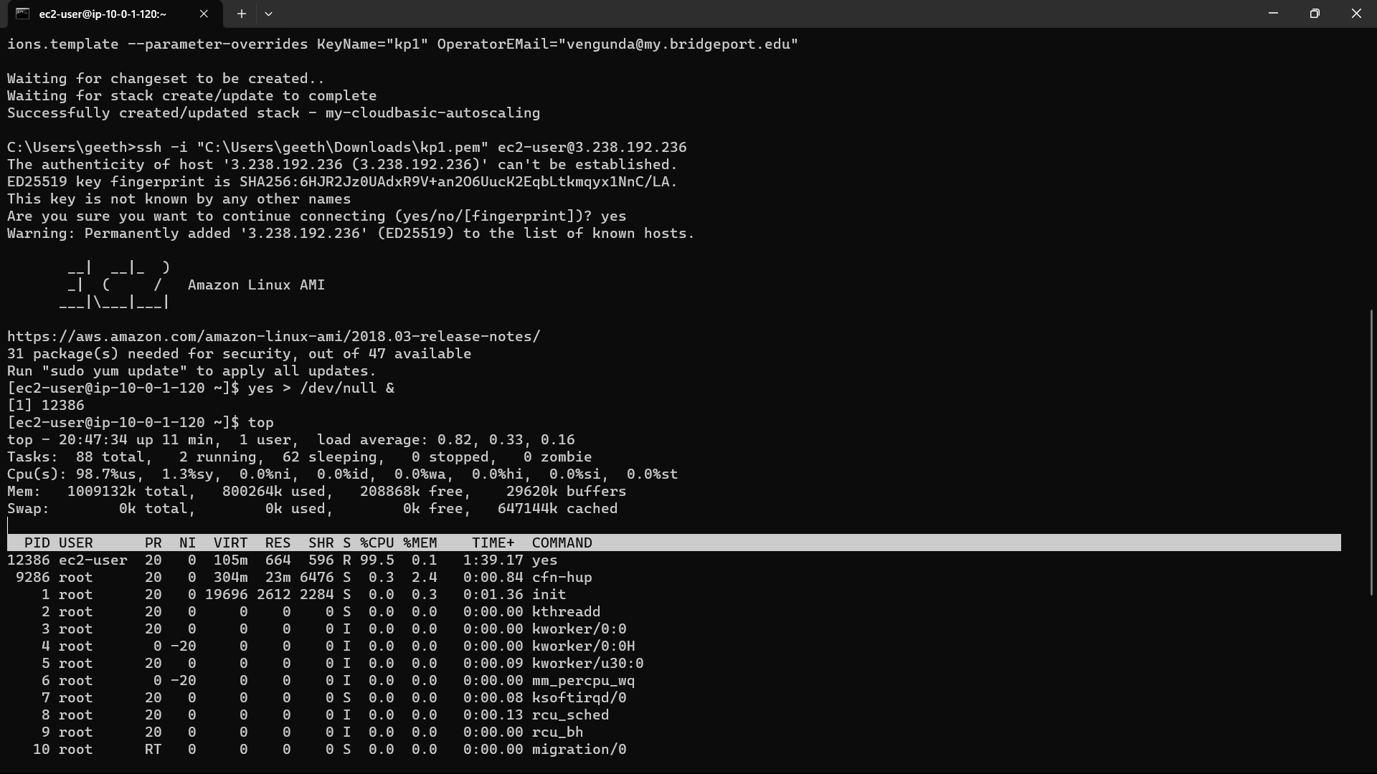

1. Due to increase of CPU another server is creates automatically.

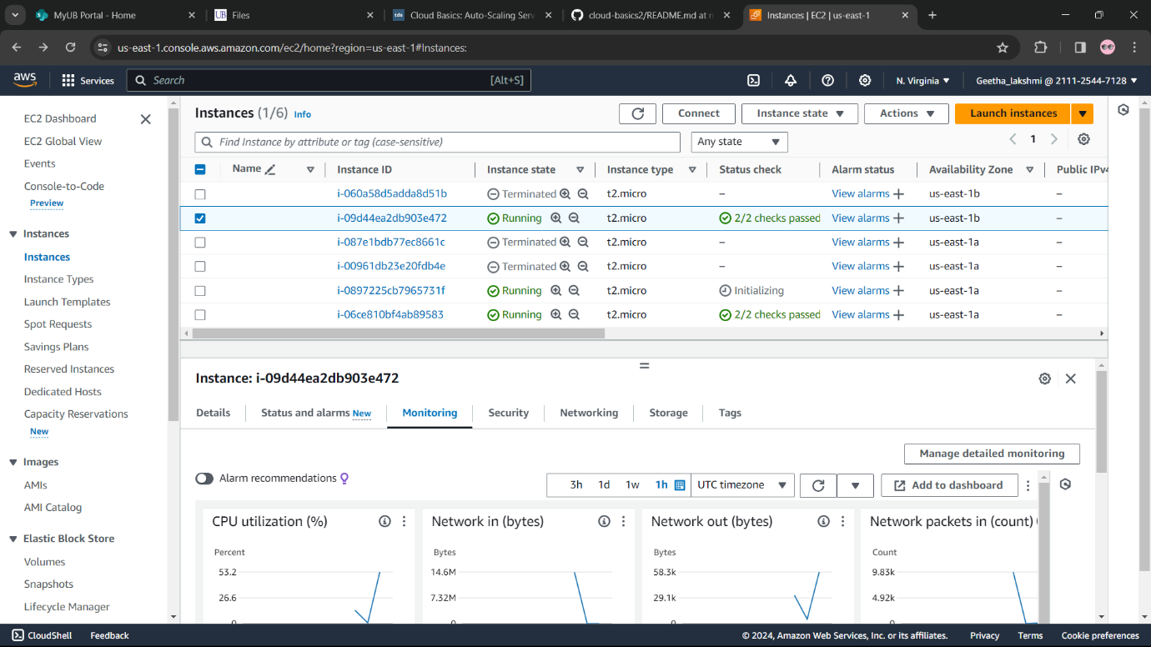

**Availability based auto-scaling:**

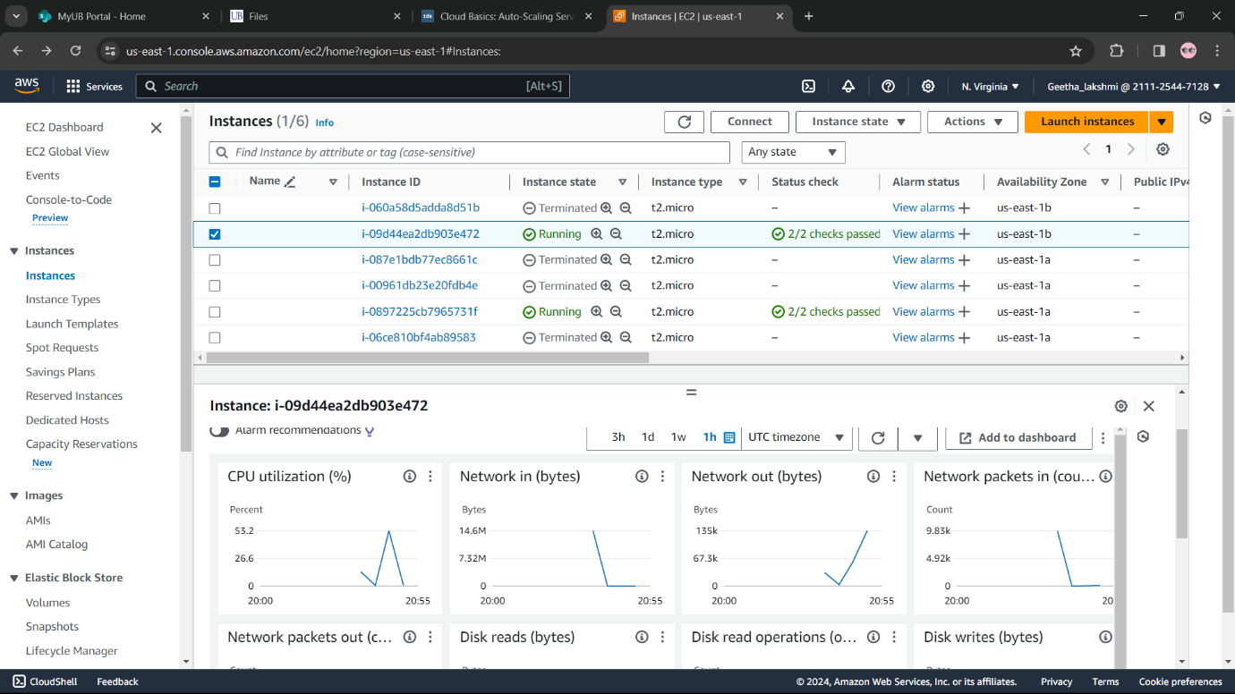

1. Eventhough, by terminating a server it’ll automatically creating server itself.

